Dear Applicant:

Applications are being accepted for George Street Commons Properties. Your application will be placed on the processing list in the order it is received. All applications will be numbered, date and time stamped in the order of receipt. For this reason, we encourage you to return your completed application to us as quickly as possible.
This application does not, in any way, obligate you or George Street Commons Properties. It does, however, give us an opportunity to determine preliminary eligibility.
Please supply all the requested information and sign the application form, Consumer Notice application Fee Policy and Guidelines and the General Release form. It is important for you to read all the forms entirely answer all questions, and be certain they are all signed.
A non-refundable fee of $13.00 per person; over the age of 18 years old will be charged once we start to process your application, This is for processing only and is not a deposit on an apartment.
As part of our preliminary processing we will do a credit check, landlord reference (if applicable), criminal background check and income calculation.
Please return your completed application to the York Area YMCA location at:

George Street Commons
ATTN: Kathy Duclo
231 S. George Street

York, PA 17401
Thanks for your interest in the George Street Commons Properties.
Sincerely,
Kathy Duclo
Director of Housing


APPLICATION FEE POLICY AND GUIDELINES

Dear Applicant:
In order to process your application and because of rising costs, we find it necessary to charge a processing fee. The fee is $13.00 for one applicant and $26.00 for two applicants, paid by money order only.

This is a NON-REFUNDABLE FEE, even if your application is rejected for any reason (over income, unacceptable credit, unacceptable references, unacceptable home visit or any other reason) or you withdraw your application. The fee is to cover costs of processing such as credit checks, criminal back ground check, home visits, reference checks, income verification and other various clerical procedures involved in placing applicants on the waiting list and processing.
By signing this memo, you are not entering into a contract, only paying a fee. The payment of this fee does not obligate George Street Commons to rent to you. You acknowledge that this fee will not be returned to you for any reason.
Our processing includes a credit check, which you must pass — if you have more than two accounts in collection or with a 4-9 rating (reflects slow payment) excluding medical collections you will be rejected. It is recommended that if you are not sure about your credit, you should check on it before you apply.
If you have questions about processing or the resident selection plan, you are encouraged to ask questions prior to submitting your application.
By signing this memo, I understand that I will not have the $13.00 or $26.00 processing fee returned to me whether I am accepted as an applicant or rejected.
Name (printed): __________________________________
Signature: _______________________________________
Date: __________ Received by: ________________________ Employee Signature

Date: __________ Time: __________

PLEASE MAKE MONEY ORDER PAYABLE TO:
George Street Commons, depending on your choice of property.
There is no guarantee that a unit is available in the specific property group you request.

George Street Commons
Please Complete this Application & Return to: FOR OFFICE use ONLY
George Street Commons Date Received: _______
231 S. George St Time Received: _______
York, PA 17401 Applicant #: _________
(717) 854-7291 Unit Size: 1 2 3 4
The following information is confidential and will not be disclosed without our consent.
Email Address: (Email is a quick and easy way to communicate. Please provide an email address for any work, and personal references you may be submitting below.)
Applicant's Name |  |  |  | Social Security No. | Home Phone
Present Street Address | City |  | State | Zip code | Years at Present Address
Former Street Address (if at present address for less than 5 yrs.) | City |  | State | Zip Code | Years at Former Address
Current Housing Status: Provide the name, address, and phone number of all your landlords for the past 3 years. Current Landlord: Phone: Address:
Previous Landlord:Phone: Address:
Previous Landlord: Phone: Address:
Name and Address of Employer |  |  |  | Type of Business | Self Employed?  Yes  No
Business Phone Number |  | Position/Title |  | No. Yrs. on Job | Years in this line of work
Name and Address of Previous Employer (if employed at present position less than 5 yrs.) |  |  |  | No. of Yrs. with  Previous Employer | Business Phone
Co-Applicant's Name |  |  |  | Social Security No. | Home Phone
Present Street Address | City |  | State | Zip Code | Years at Present Address
Former Street Address (if at present address for less than 5 yrs.) | City |  | State | Zip Code | Years at Former Address
Name and Address of Employer |  |  |  | Type of Business | Self-employed?  Yes  No
Business Phone Number |  | Position/Title |  | No. Yrs. on Job | Yrs. in this line of work
Name and Address of Previous Employer (if employed at present position less than 5 yrs.) |  |  |  | No. of Yrs. with  Previous Employer | Business Phone

List the head of your household and all members who live in your home; Give the relationship of each family member to the head.
MEMBER NO. | FULL NAME | RELATIONSHIP | BIRTHDATE M/D/Y |  | SOCIAL  SECURITY NO.
Head of Household
2
3
4
5
6
7
PLEASE LIST MOTHER'S MAIDEN NAME OF ALL ADULT'S
YOUR FULL NAME |  | YOUR MOTHER'S MAIDEN NAME
1.
2.
3.

Have you ever been denied for housing with George Street Commons before?
Yes _____ No _____

Do you own the home where you currently reside? Yes _____ No _____

Do you own a home or other property? Yes _____ No _____
Are you or any member of your household currently using an illegal substance? Yes _____
No _____
Are you or any member of your household currently abusing alcohol? Yes _____ No _____
Have you or any member of your household been convicted of drug use or manufacture or any other felony? Yes _____ No _____

Have you or any member of your household been convicted of any crime in the past five years?
Yes_____ No _____
(note: any crime includes ALL crimes, misdemeanor, summary offense & felony)
Have you or any member of your household been convicted of any misdemeanors? Yes _____ No _____

Have you or any member of your household ever been evicted from any housing? Yes _____ No _____

Are you or any member of your household registered with any State as a Sexual Offender?
Yes _____ No _____ If yes, which state(s)?

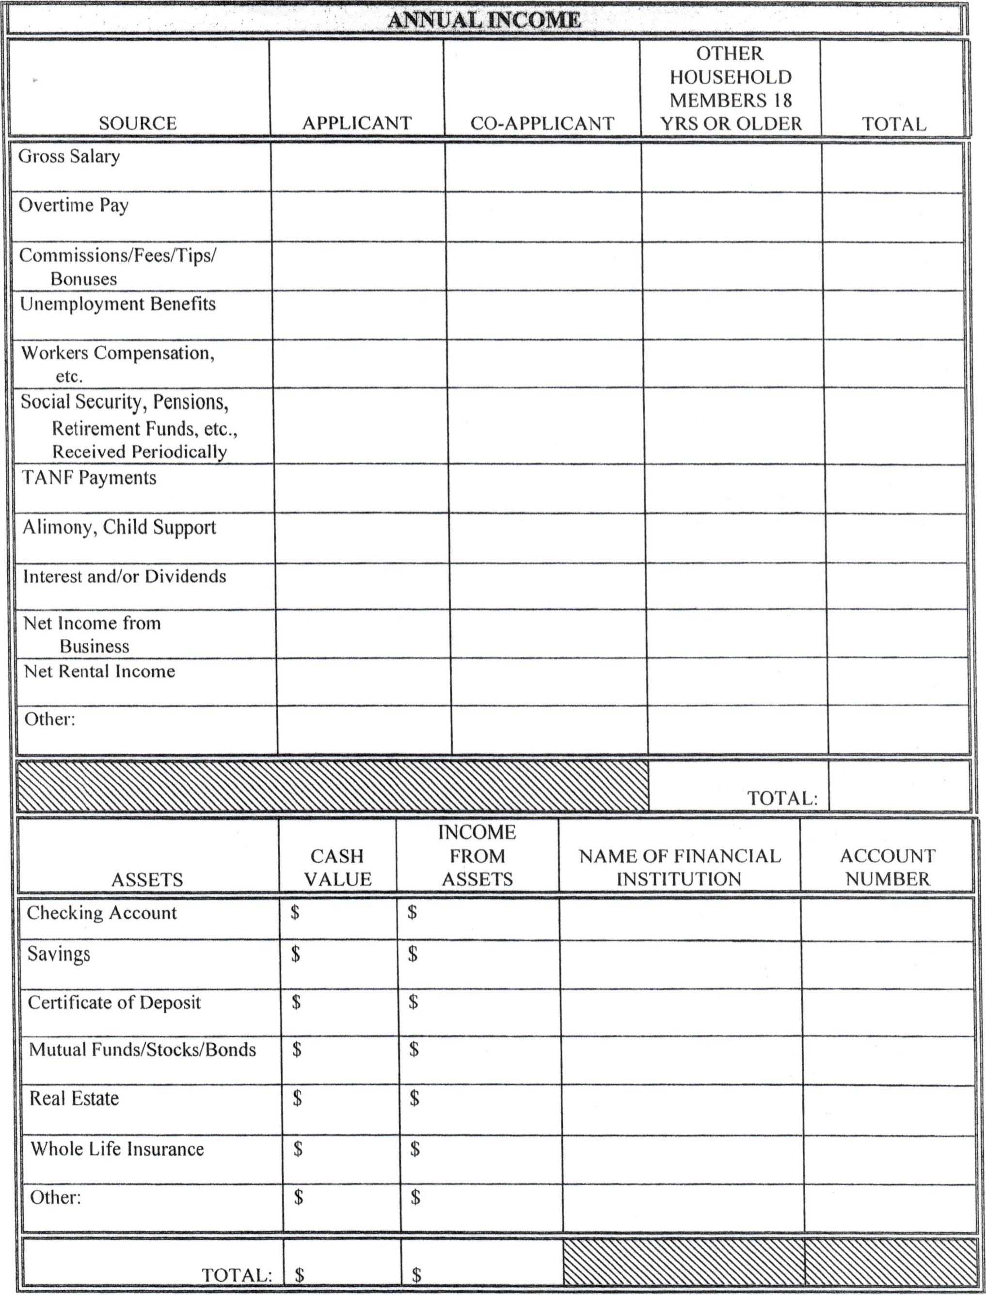

Are mere any special housing needs or reasonable accommodations that the household will require? If yes, list below:
___________________________________________________________________________________________________________________________________________________________________________________________________________________________________________________________________________
Comments or additional information: ________________________________________________________________________________________________________________________________________________________________________________________________________________________________________________________________________
The information provided in this application is true and complete to the best of my/our knowledge and belief. I/we consent to the disclosure of income and financial information from my/our employer and financial references for purposes of income and asset verification related to my/our application for tenancy. I/we understand that in order to be considered for housing we must pass all the resident selection criteria including a home visit/inspection, credit check, landlord reference, criminal background check, and income qualification. I / we understand that if information is missing (intentional or not), incomplete, or falsely reported on this rental application I/we shall be immediately rejected for consideration of housing. I/we understand that this application gives George Street Commons permission to verify all the information included within the application and other information requested during the processing of the application. I/we understand that this application is not an approval for housing.
PERSONS AGE 18 AND OLDER MUST SIGN THIS APPLICATION

Applicant (Head of Household): ___________________________________ Date: __________

Co-Applicant: _________________________________________________ Date: __________
Co-Applicant: _________________________________________________ Date: __________

In accordance with the data collection information required by the Department of Housing and Urban Development (HUD), please provide the following information for the head of household. It is for data collection only. Please report the head of household statistics only at this time.

Race

- White
- Black or African American
- Asian
- American Indian or Alaska Native
- Native Hawaiian or other Pacific Islander
- Other / Multi Racial

Ethnicity

- Hispanic o Latino
- Not Hispanic or Latino

Gender

- Male
- Female

CONSENT: I authorize and direct any business; individual; federal, state or local agency, department or organization to release to GSC any information or materials needed to complete and verify my application for tenancy, my eligibility and continued eligibility for tenancy, and my certification and recertification for assistance, if applicable. I give my consent for the release of such information about the minor children in my care who live with me. I understand and agree that this authorization or the information obtained with its use may be given to and used by any federal, state, or local housing assistance agency and the owner and management agent in administering and enforcing program and owner and management agent rules and policies.
INFORMATION COVERED: I understand that, depending on program policies and requirements, previous or current information regarding me or my household may be needed. Verifications and inquiries that may be requested include but are not limited to:
Identity and marital status Employment income and assets Credit and criminal Activity
Residences and rental activity Medical or childcare allowances Social Security number
Sexual Offender Status Criminal history

GROUPS OR INDIVIDUALS THAT MAY BE ASKED: the groups or individuals that may be asked to release the above information (depending upon program requirements) include but are not limited to:

Previous landlords, including public housing agencies Past and present employers
Veteran’s Administration Welfare Agencies Banks and other financial institutions
Retirement systems Post Offices Social Security Administration
State unemployment agencies Schools and colleges Credit providers and credit bureaus
Support and alimony providers Utility companies Medical and childcare providers
Police departments and agencies which retain criminal histories and sexual offender registries

COMPUTER MATCHNG NOTICE AND CONSENT: I understand and agree that HUD or a public Housing Authority (PHA) may conduct matching programs to verify the information supplied for my certification or recertification. If a computer match is done, I understand that I have a right to notification of any adverse information found and a chance to disprove incorrect information. HUD or the PHA may in the course of its duties exchange such automated information with other federal, state, or local agencies, including but not limited to: State employment security agencies, Department of Defense, Office of Personnel Management, United States Post Office, Social Security Administration, State welfare and food stamp agencies

CONDITIONS: I agree that a photocopy of this authorization may be used for the purposes stated above. The original of this authorization is on file with the management office and will stay in effect for a year and one month from the date signed. I understand I have a right to review my file and correct any information that I can prove is incorrect.

SIGNATURES:

______________________________ ______________________________ __________
Head of Household Print Name Date

______________________________ ______________________________ __________
Spouse Print Name Date

______________________________ ______________________________ __________
Adult Member Print Name Date

I hereby certify that the following minor children are living with me: _____________________________________

____________________________________________________________________________________________

NOTE: THIS GENERAL CONSENT MAY NOT BE USED TO REQUEST A COPY OF A TAX RETURN. IF A COPY OF A TAX RETURN IS NEEDED, IRS FORM 4506, “REQUEST FOR COPYOF TAX FORM” MUST BE PREPARED AND SIGNED SEPERATELY.

